AWS Networking Infrastructure
To ensure high availability, the architecture uses a /16 Custom VPC carved into 6 subnets across 2 distinct Availability Zones (AZs), with each subnet provisioned with a /24 block (providing 251 usable IPs per subnet)
VPC CIDR Block: 10.0.0.0/16

Subnet Distribution:
- Public Web Tier: 10.0.0.0/24 (AZ-1) & 10.0.1.0/24 (AZ-2)
- Private App Tier: 10.0.2.0/24 (AZ-1) & 10.0.3.0/24 (AZ-2)
- Private DB Tier: 10.0.4.0/24 (AZ-1) & 10.0.5.0/24 (AZ-2)
Internet Gateway (IGW): Attached to the VPC to enable public routing.
- NAT Gateway: Allocated a static Elastic IP (EIP) and deployed strictly inside a Public Subnet (10.0.0.0/24) to give private tiers secure, outbound-only internet access for running package update.

VPC Snap
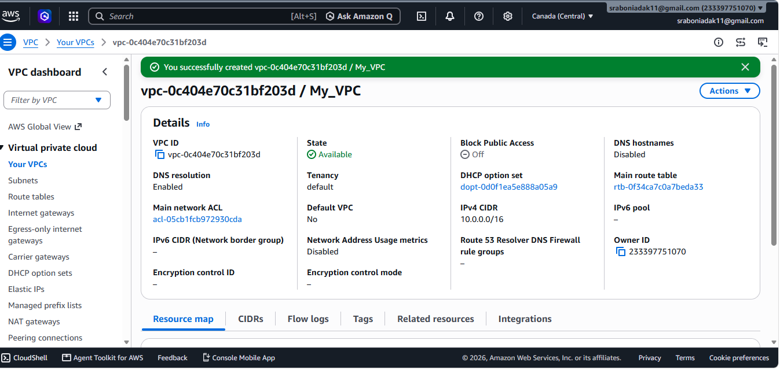

Subnet Snap
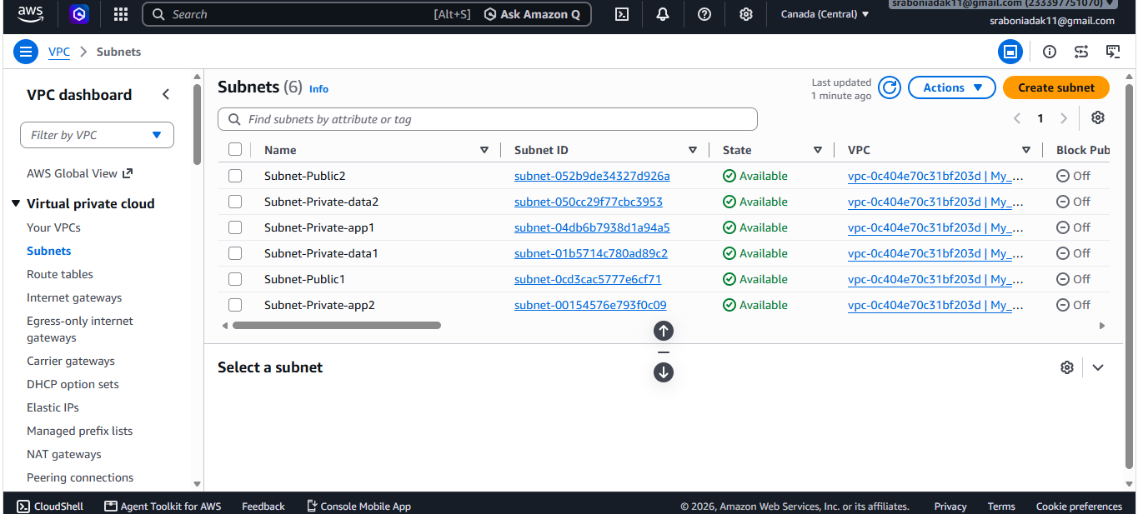

EIP Snap
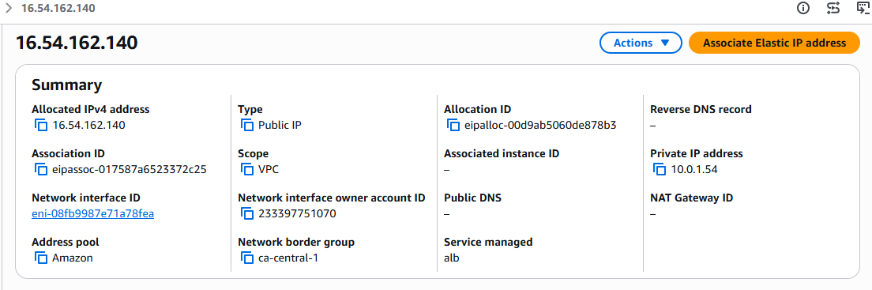

Internet Gateway Snap
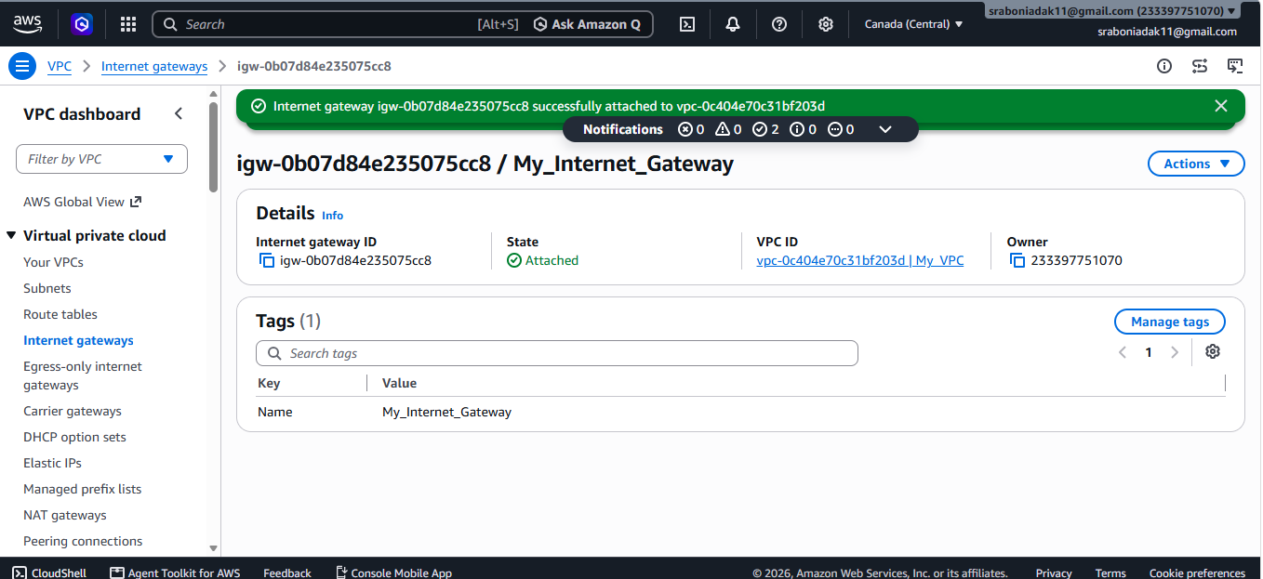

NAT Gateway Snap
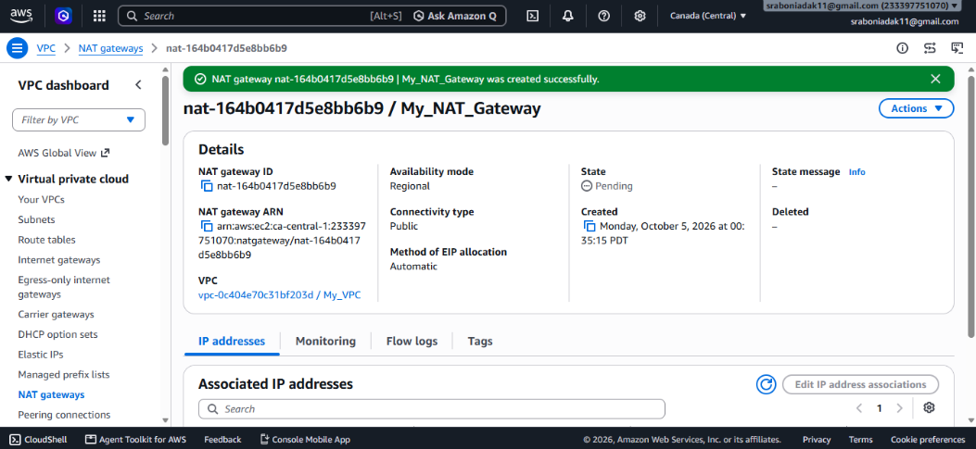

Network Routing Tables:-
Route Table Name | Associated Subnets | Destination Target Mapping
Public Route Table | Public Web Subnets 1 & 2 | 0.0.0.0/0 → Internet Gateway (IGW)
Private App Route Table | Private App Subnets 1 & 2 | 0.0.0.0/0 → NAT Gateway
Private DB Route Table | Private Database Subnets 1 & 2 | No external default route (Isolated internally)

Network & Instance Security Profiles:-

Security Group | Direction | Protocol | Port | Source
Public ALB SG | Inbound | TCP | 80 | 0.0.0.0/0
Public ALB SG | Inbound | TCP | 443 | 0.0.0.0/0
Public ALB SG | Outbound | All | All | Web SG
Web SG | Inbound | TCP | 80 | Public ALB SG
Web SG | Inbound | TCP | 22 | Your IP (only if using SSH)
Web SG | Outbound | TCP | 5000 | Internal ALB SG & all traffic0.0.0.0/24
Internal ALB SG | Inbound | TCP | 5000 | Web SG
Internal ALB SG | Outbound | TCP | 5000 | Application SG
Application SG | Inbound | TCP | 5000 | Internal ALB SG
Application SG | Inbound | TCP | 22 | Bastion SG (if using bastion)
Application SG | Outbound | TCP | 3306 | RDS SG
RDS SG | Inbound | TCP | 3306 | Application SG
RDS SG | Outbound | All | All | 0.0.0.0/0

Security Group snap:-
